Little Lemon scenario

In this reading, you will learn how to present a scenario and a customer journey map documenting user requirements. You have already learned that scenarios define the stories and context that lead to a particular user or user group visiting your website. They help you make a list of the objectives and questions that need to be answered. Here are two Little Lemon scenarios.

**Scenario 1**

Tilly has come home from a long hard day at work. She is hungry, tired and low on groceries. She has been craving a healthy meal all day and decides to treat herself to a meal from Little Lemon, her favorite local restaurant.

**Customer journey**

A customer journey map is a graphical representation of how a customer interacts with your brand at various stages. These visuals tell a story about how a customer moves through and experiences each interaction phase. Touchpoints and moments of truth, as well as potential customer feelings, such as frustration or confusion, should be included in your customer journey map. You should also include any actions you want the customer to take.

Customer journey maps are frequently based on a timeline of events. For example, it starts with the moment the customer accesses the website. Then you document their progression when trying to achieve their goals, going anywhere from viewing the product or dish they want, its customization, signing up for the website, and even canceling an order. These are just some of the actions you may want to perform while using the website, but there could be many others.

The best customer journey maps are detailed and granular, and they help you understand the customer experience at every stage. Although there are different kinds of journey maps, they typically share these five elements.

**Actor**

The persona or user who goes on the journey is the actor. The journey map is about the actor — their point of view. Actors typically align with personas, and their actions on the map are data-driven. In the example you will explore below, Tilly is the actor.

To create a strong, clear narrative, you should provide one point of view per map: The Little Lemon in this instance. For example, you have Tilly as an actor and her journey while using the website. You create an individual map for each actor you have.

**Scenario and expectations**

The scenario describes the situation the journey map addresses and is associated with an actor's goal or need and specific expectations. For example, Tilly is ordering a meal online. And her expectation includes being able to easily find all the information required to make a decision and complete her order.

**Journey phases**

The journey phases are the various high-level stages of the journey. They organize the rest of the information in the journey map: actions, thoughts, and emotions. The phases will differ depending on the scenario.

**Actions, attitudes and emotions**

These are the actor's behaviors, thoughts, and feelings throughout the journey, mapped within each journey phase. Users' actions are their actual behaviors and steps. This part is not intended to be a detailed step-by-step list of each distinct interaction. Instead, it is a narrative of the actor's actions during that phase. At various stages, mindsets correspond to users' thoughts, questions, motivations, and the information they need. Ideally, these are direct quotes from customers.

**Opportunities**

Opportunities, along with additional contexts such as ownership and metrics, are mapping insights that inform how the user experience can be improved. Insights and opportunities assist the team in extracting knowledge from the map:

* What should be done with this information?
* Where can you find the best opportunities?

**Customer journey map**

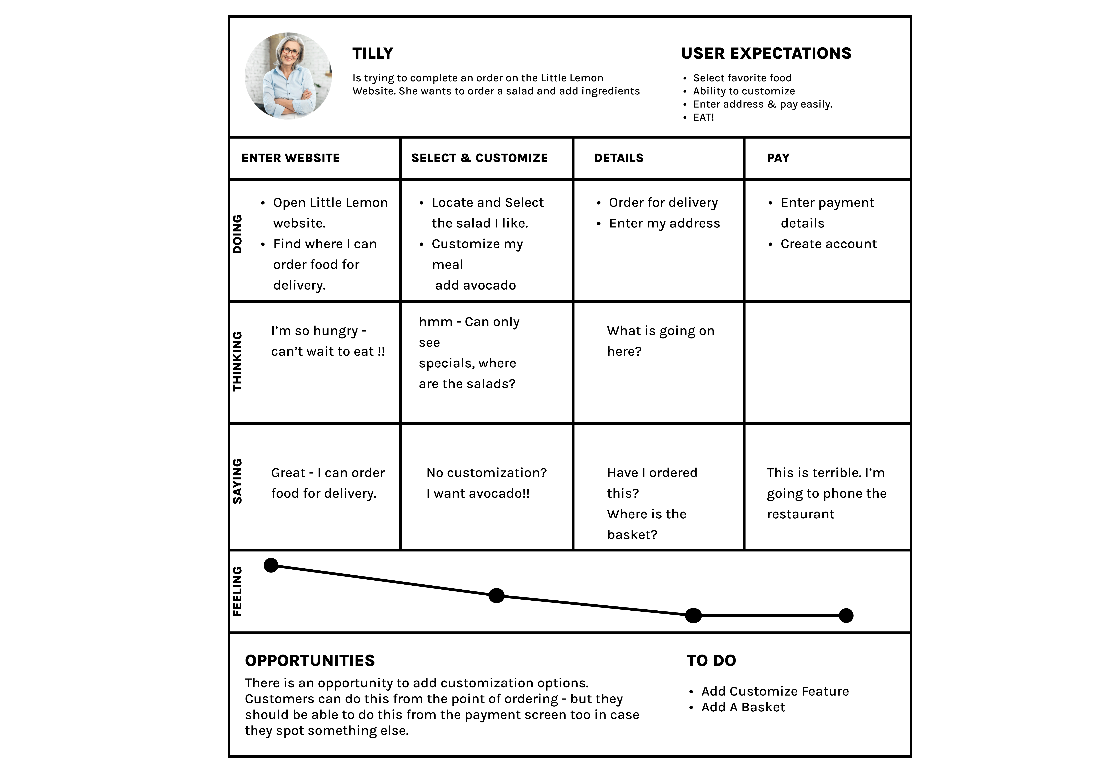

**Final thoughts**

Journey mapping uncovers moments of frustration and delight in a series of interactions to provide a detailed view of the customer experience. When executed correctly, it reveals opportunities to address customer pain points, reduce fragmentation and improve the user experience.